Production text long version:

Le Sacre du Printemps, a ballet for a single body
I can feel it – gonna take you down.

101 years ago Stravinsky composed and Nijinsky choreographed “Le Sacre du Printemps”, a ballet that broke all conventions at that time. The oeuvre is divided into two parts; “The Adoration of the Earth” and “The Sacrifice”.
The first part is all about the society and therefore I have chosen the form of a solo as an oppositional element that is able to interrogate and play with the individual representation and imaginary energy of the group. The singular body is representing the whole ensemble of the original ballet by asking – How many bodies can the singular body be or represent? I am the core of the ballet. I am the dancer, the ensemble, the old wise man, the witch, the peacock and the bear. I am the only one dancing the rite of spring.
The second part “The Sacrifice” introduces a further working element, namely the Heavy Metal culture. Common aspects of Heavy Metal and “Le Sacre du Printemps” are a ritualistic structure as well as an archaic energy and gestural movement vocabulary. “The Sacrifice” is constructed as a solo that negotiates the body within the sacrificing dance, a body that comes to a point of exhaustion, a no more, game over!

(1.162 caracters)

Production text short version:

Le Sacre du Printemps, a ballet for a single body
I can feel it – gonna take you down.

101 years ago Stravinsky composed and Nijinsky choreographed “Le Sacre du Printemps”, a ballet that broke all conventions. It consists of two parts: “The Adoration of the Earth” and “The Sacrifice”.
The 1st part is all about the society and therefore I have chosen the form of a solo as an oppositional element that is able to interrogate and play with the individual representation and imaginary energy of the group. The singular body is representing the whole ensemble of the original ballet. The 2nd part “The Sacrifice” introduces a further working element, namely the Heavy Metal culture. It is constructed as a solo that negotiates the body within the sacrificing dance, a body that comes to a point of exhaustion, a no more, game over!

(742 caracters) – I could not make it shorter

Credits:
Concept, choreography, performance – Lea Moro
Lightdesign – Annegret Schalke
Dramaturgical Advice – Linda Sepp, Maja Zimmermann, Alice Chauchat, Josep Caballero Garcia, Désirée Meul
Costume – Lydia Sonderegger
Music – Igor Stravinsky „Le Sacre du Printemps“, Songtext Black Sabbath „When Death Calls“
Executive Producer – Marie Schmieder

With the kind support of Kulturstiftung des Bundes. First part performed in the frame of Tanz über Gräben. 100 Jahre Le Sacre du Printemps (November 2013, HAU Hebbel am Ufer Berlin).
Supported by – Ernst Göhner Stiftung, Fondation Nestlé pour L ́Art, HAU Hebbel am Ufer, German Federal Cultural Foundation, Inter-University Centre for Dance Berlin.

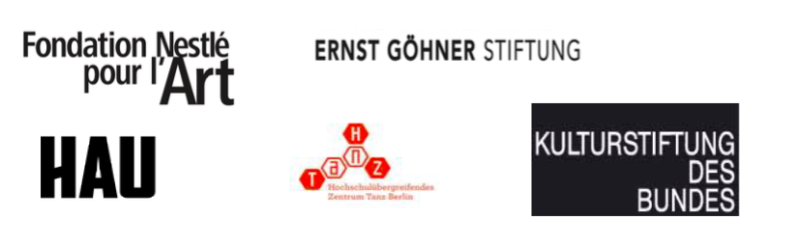

CV Lea Moro – long version:

Lea Moro is a performer and choreographer from Switzerland, based in Berlin and Zurich. She studied at the Scuola Teatro Dimitri (BA in Physical Theatre), LABAN Centre London (Diploma in Dance Studies) and graduated 2014 from the Inter-University Centre for Dance Berlin (BA Dance, Context, Choreography). Her choreographic work „(b)reaching stillness“ (2015) was invited to the German Dance Platform 2016. In 2015/16 Lea Moro was artist in Residence at the K3 Centre for Choreography I Tanzplan Hamburg and developed the solo musical „The End of the Alphabet“. In 2013/14 she created the solo performance „Le Sacre du Printemps, a ballet for a single body“. Lea Moro's work is touring internationally a.o. Tanzhaus Zürich, Dampfzentrale Bern, Festival Moving in November Helsinki, Colombo Dance Platform in Sri Lanka, Festival Tanztage Berlin, HAU Hebbel am Ufer Berlin, Kampnagel Hamburg, Arsenic Lausanne. Lea Moro is nominated talented choreographer within the year book 2015 of tanz magazine. In the same year she received the Elsa-Neumann scholarship of the city Berlin, in 2014 the DanceWEB scholarship during the Festival ImPulsTanz in Vienna, from 2014 - 2016 she was supported by the PAP Mentoring Program Berlin and in 2016 she receives a research-scholarship of the senate Berlin. Lea Moro co-founded the Acker´Festival Berlin (2013/14), between 2012-14 she was a council member of the Academic Senate / Extended Academic Senate of the Berlin University of the Arts and since 2014 she is part of the curatorial team for the residency program Schloss Bröllin.

www.leamoro.com

CV Lea Moro – short version:

Lea Moro is a swiss performer and choreographer, based in Berlin and Zurich. Her choreographic work „(b)reaching stillness“ (2015) was invited to the German Dance Platform 2016. In 2015/16 Lea Moro was artist in Residence at the K3 Centre for Choreography and developed „The End of the Alphabet“. In 2013/14 she created „Le Sacre du Printemps, a ballet for a single body“. All her works are touring internationally.
Lea Moro is nominated talented choreographer within the year book 2015 of tanz magazine.

www.leamoro.com

